**How To Create AWS Free Tier Account**

This post covers the **AWS Free Tier Account** Overview. Amazon Web Services (AWS) is providing 12 months of Free Tier account to new subscribers to get hands-on experience with all the AWS cloud services.

In this AWS Free Tier account Amazon is giving no. of deferent services use with some of the limitations to get hands-on practice and more knowledge on AWS Cloud services as well as regular business use. The AWS Free Tier is mainly designed to give hands-on experience with AWS Cloud Services for customers free of cost for a year. With the AWS Free Tier account, all the services are offered have limited on what we can use without being charged.

**REGISTER FOR AWS FREE TIER ACCOUNT**

**1.** First Open your web browser and navigate to [**AWS Free Tier Page**](https://aws.amazon.com/free/?all-free-tier.sort-by=item.additionalFields.SortRank&all-free-tier.sort-order=asc)  
**2.** On middle-click on Create a Free Account

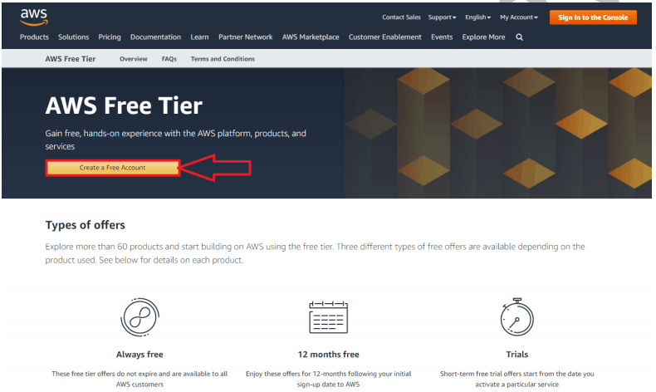

**3.** Issue the details which you want to use for login your AWS account and click on Continue  
• **Email address:** Provide the mail id which hasn’t registered yet with Amazon AWS.  
• **Password:** Type your password.  
• **Confirm password:** Authenticate the password.  
• **AWS Account name:** Choose a name for your account. You can change this name in your account settings after you sign up.

**4.** Contact Information  
Select your AWS type (Professional/ Personal) Fill in the correct information to validate your account if you’re going to create personal use then click on “personal Account” else use “Company Account”, Accepts the Terms and  
condition and then click on Create Account and Continue

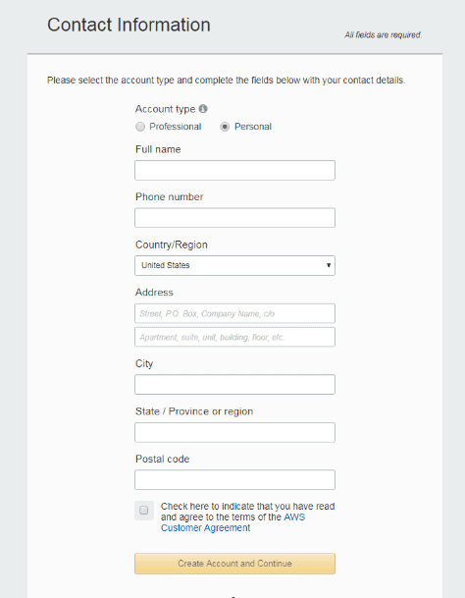

**Note:** Make sure to provide proper contact details and mobile number to get the Verification code from AWS.  
**5.** Payment and PAN information: In this step, you must fill in your credit card /Debit Card info and billing address and click on Secure Submit.

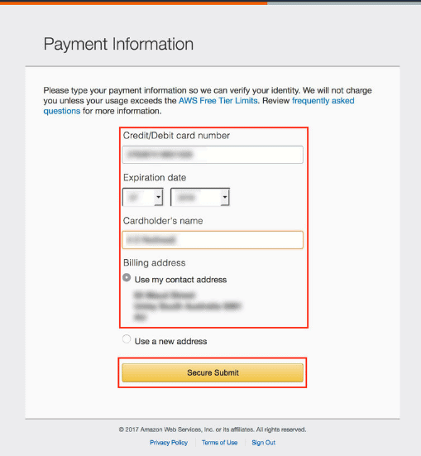

**6.** In this step, it will take you to the payment gateway to validate your payment information and for your credit card verification, Amazon will charge the minimum price based on Country. Here I have provided India, so Amazon charged 2 INR.

**7.** Phone verification: Here you will be taken to an identity verification page that will already have your phone number, so you just have to select either “Text message or Voice call” Provide a valid phone number, Solve the captcha and then click on Send SMS or Call Me Now(depending upon your selection).

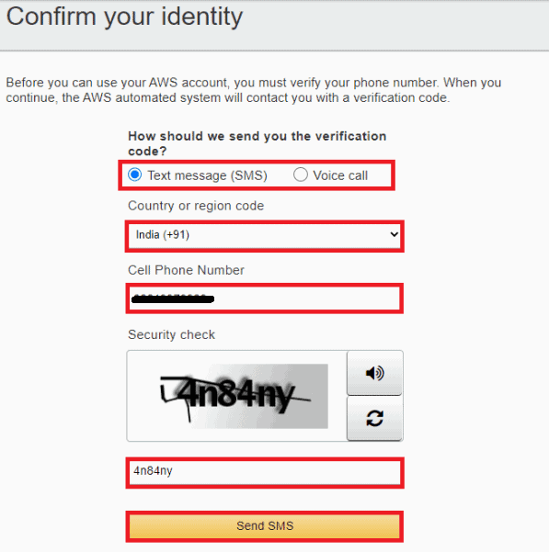

**8.** After clicking on Send SMS or Call me Now, you will immediately receive a call or SMS from Amazon, for verification code, Enter your code then click on Verify Code.

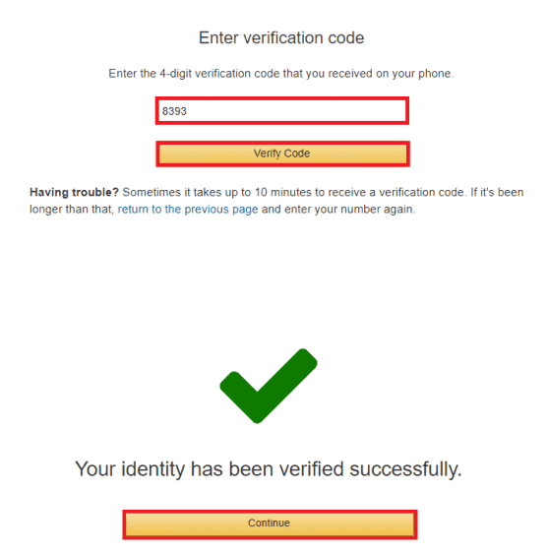

**9.** Support plan: AWS support offers a selection of plans to meet your business needs.  
Select your suitable plan then click continue.

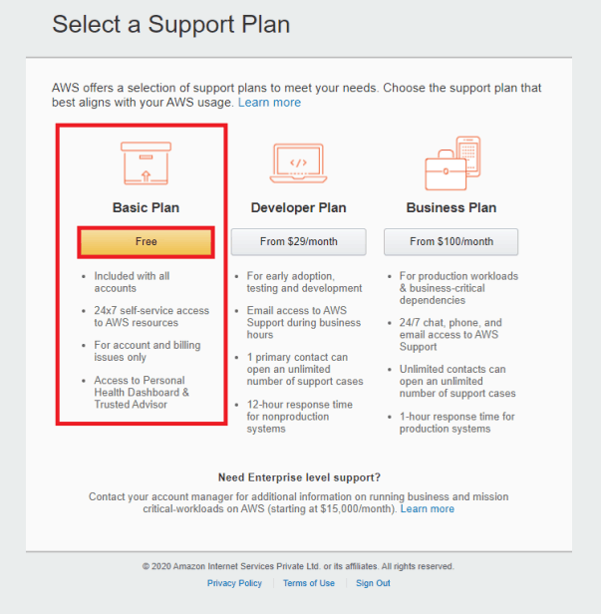

**Note:** All customers receive free basic support.  
**10**. Registration Confirmation page.  
Once you completed all the above steps and processes. You’ll get the confirmation page as below. Now your account will be processed for activation. It may take somewhere between 30 minutes to 1 hour for you to receive an email confirmation that your Amazon Cloud Services account has been activated.

